LJ University
Department of Computer Applications

MediMart: An Online Healthcare Platform.
MASTER OF COMPUTER APPLICATION (INTEGRATED)

GROUP MEMBERS | Kaushal Pithva  Hamza Vora
SUBMITTED TO | Jhanvi Shukla
ACADEMIC YEAR | 2024 -2027
SUBMISSION DATE
DIV-ROLL NO. | F31, F48

INTERNAL GUIDE

TABLE OF CONTENTS
1. Introduction
1.1 Existing System
1.2 Need for the New System
1.3 Objective of the New System
1.4 Problem Definition
1.5 Core Components
1.6 Project Profile
1.7 Assumptions and Constraints
1.8 Advantages and Limitations

2. Project Planning
2.1 Team Details and Roles
2.2 Proposed Timeline (Gantt Chart)

3. Requirement Determination & Analysis
3.1 Requirement Determination
3.2 Targeted Users

4. System Design
4.1 Use Case Diagram
4.2 Class Diagram
4.3 Interaction Diagram
4.4 Activity Diagram
4.5 Data Dictionary

5. Development
5.1 Development Approach
5.2 Coding Standards
5.3 GitHub Repository Details
5.4 AI Tools/Libraries/APIs Used (if any)
5.5 Screenshots & Implementation Details

6. Proposed Enhancements

7. Conclusion

8. Bibliography

1. INTRODUCTION
This document describes the current MediMart implementation: a Django and MySQL healthcare marketplace with product discovery, seller offers, prescription review, checkout, delivery, lab bookings, doctor consultations, health records, notifications, support, and role-scoped operations. It records the implemented workflows and database concepts so that customers, professional users, administrators, developers, and evaluators can understand how the website works.
MediMart is an independent academic implementation inspired by common digital-health marketplace patterns. The current application uses Django server-side views and forms, MySQL relational storage, Bootstrap and project CSS for responsive presentation, and JavaScript for progressive interactions. It includes a guarded AI assistant and catalogue search, but AI does not replace a clinician, pharmacist, payment verification, or the database as the source of truth.

1.1 Existing System
The existing healthcare purchasing and consultation environment is fragmented across local pharmacies, diagnostic laboratories, hospitals, physician clinics, phone calls, paper prescriptions, and separate digital services. Users often repeat the same patient and address information across different providers and may need separate communication channels for medicine availability, diagnostic appointments, and doctor consultation. In many smaller organizations, stock checking, prescription verification, booking confirmation, and follow-up communication are still handled through spreadsheets, calls, messaging applications, or manual records.
Workflow of the fragmented process that MediMart consolidates:
1. Product or medicine search: The customer identifies a medicine, wellness product, or diagnostic requirement through a local pharmacy, printed information, telephone inquiry, or a separate website.
2. Availability and price confirmation: The customer contacts a provider or checks multiple sources to determine availability, price, dosage or package information, and service details.
3. Prescription verification: For prescription-required medicines, the customer provides a paper or digital prescription to the pharmacy for manual validation.
4. Lab test booking: The customer selects a diagnostic centre, calls the centre, confirms a test package and appointment slot, and shares patient details and address information.
5. Doctor consultation: The customer separately searches for a doctor, contacts the clinic, or books an appointment through another service.
6. Record keeping and follow-up: Reports, prescriptions, consultation notes, and order details are stored in different places, making long-term tracking difficult.

1.2 Need for the New System
· Fragmented healthcare workflows require users to switch between pharmacies, laboratories, clinics, and communication channels.
· Manual prescription handling can create delays and make verification status difficult for both customers and operations staff to track.
· Medicine availability, prices, test slots, doctor schedules, and service information may be distributed across different sources instead of one searchable platform.
· Customers may not have a single account view containing orders, prescriptions, lab bookings, consultation history, and health documents.
· Administrators and partner organizations need centralized control over catalog data, inventory, bookings, users, provider verification, and operational records.
· A responsive web platform can reduce repeated data entry, provide consistent workflows, and improve visibility of order and booking status.

1.3 Objective of the New System
The current objectives of the MediMart platform are:
Unified healthcare access: Provide one account for medicines, medical equipment, lab tests, consultations, health records, and support.
Secure account management: Provide username, email, or phone login, password reset, optional TOTP MFA, profiles, addresses, sessions, and role-based permissions.
Marketplace fulfilment: Support catalogue search, seller offers, filters, cart, prescription gates, inventory reservation, payment, invoice, delivery tracking, returns, and refunds.
Lab services: Support test discovery, partner branches, collection slots, home collection, booking status, sample tracking, reports, and invoice records.
Doctor services: Support verified doctor profiles, consultation scheduling, status changes, private messages, attachments, notes, advice, and follow-up periods.
Health records: Support dependents, tagged records, prescriptions, lab reports, reminders, sharing controls, and private media delivery.
Operations control: Provide capability-controlled CRUD panels for users, catalogue, sellers, licences, prescriptions, orders, fulfilment, labs, consultations, payments, refunds, support, notifications, and audits.
Reliable processing: Use Django validation, transactions, CSRF protection, private media checks, audit events, database constraints, pagination, and MySQL-backed persistence.

1.4 Problem Definition
MediMart is a full-stack Django application backed by MySQL. Its scope covers the customer marketplace, seller onboarding, clinical review, fulfilment, laboratory services, consultations, records, notifications, support, and operations. The application boundary ends at the software workflow: licensed partners and qualified professionals remain responsible for real-world dispensing, sample collection, diagnosis, delivery handoff, and legal compliance.

1.5 Core Components
MediMart is structured into the following integrated applications and business modules:
Module | Current responsibility
Accounts and security | User profiles, role assignment, username/email/phone login, password reset, TOTP MFA, addresses, sessions, and access control.
Catalogue and marketplace | Products, categories, brands, images, clinical metadata, seller offers, stock, safety flags, search, comparison, and equipment views.
Prescription and clinical review | Private prescription upload, scan metadata, product mapping, pharmacist review, clarification, approval, rejection, and fulfilment limits.
Cart, payments, and orders | Cart, coupons, totals, inventory reservation, Razorpay verification, invoices, order history, returns, refunds, and status timeline.
Delivery and fulfilment | Warehouses, batches, shipments, delivery assignment, OTP, proof of delivery, cold-chain records, and allowed transitions.
Healthcare services | Lab partners, tests, slots, bookings, phlebotomy workflow, doctors, consultations, messages, dependents, records, reminders, and care plans.
Operations and support | Capability-controlled CRUD, seller/licence review, catalogue approval, support tickets, notifications, audit events, reports, and configuration.
AI assistance | Guarded catalogue search and account-aware assistant responses. Private account-status answers are generated from the signed-in user's records without an unnecessary external call.

1.6 Project Profile
Attribute | Current details
Project name | MediMart healthcare marketplace and care-services platform
Project type | Full-stack web application
Backend | Python Django with modular applications, forms, views, services, and migrations
Database | MySQL
Frontend | HTML templates, Bootstrap, project CSS, Bootstrap Icons, and JavaScript
Payments | Razorpay Standard Checkout with server-side verification
Authentication | Django authentication with username, email, phone identifier resolution, password reset
AI | OpenAI-compatible or configured provider endpoint, one configured primary model, local catalogue fallback, caching, and request deduplication
Storage | Static assets, public media, and permission-checked private media for health documents
Deployment scope | Local development at 127.0.0.1:8000; production requires separate credentials, storage, monitoring, policies, and operational approvals

1.7 Assumptions and Constraints
Assumptions:
· Users have an active internet connection and a modern web browser.
· Customers provide accurate profile, address, prescription, and appointment information.
· Authorized staff or partner users verify prescription and provider-related information before the final operational action where verification is required.
· The project stores product, test, doctor, booking, and order information in the MySQL database.
Constraints:
· The system is primarily a web-based academic project and depends on network availability for online workflows.
· Actual medicine dispensing, laboratory sample collection, and medical diagnosis are outside the software system boundary.
· External healthcare, logistics, notification, or payment integrations are optional and should only be considered when the required API credentials and agreements are available.
· Health-related information must be handled according to the security and privacy requirements applicable to the deployment environment.

1.8 Advantages and Limitations
Advantages:
· Provides a unified digital access point for medicines, lab tests, doctor consultation, and health records.
· Reduces repeated manual entry and improves tracking of orders, bookings, prescriptions, and consultation activities.
· Provides role-based administration and centralized monitoring for healthcare platform operations.
· Uses Django security mechanisms, server-side validation, and relational constraints to improve application integrity.
· Responsive Bootstrap/Tailwind UI supports desktop and mobile browser access.
Limitations:
· Requires internet connectivity for web-based transactions and consultation communication.
· The software cannot replace professional medical diagnosis or physical laboratory procedures.
· Availability, delivery, appointment fulfillment, and report generation depend on pharmacy, laboratory, and doctor partner operations.
· Advanced real-time communication, notification, payment, and external-provider integrations may require additional APIs or services.

2. PROJECT PLANNING

2.1 Team Details and Roles
Name of the Student | Role of the Student
Kaushal Pithva | Backend Developer and Database designer
Hamza Vora | Frontend Developer, UI/UX, Tester, Documentation Lead

2.2 Proposed Timeline
The project follows an iterative academic development cycle: requirements and role design, database and workflow design, Django implementation, responsive UI work, integration testing, data seeding, documentation, and review. The current source remains the authority when an earlier plan differs from the running project.
 | M1 | M2 | M3 | M4 | M5 | M6
Planning
Topic Selection & Approval
Requirement Analysis
System Design
System Design (UML, Database, UI)
Development

Frontend Development
Backend Development
Database Implementation
Testing

Integration & Testing
Bug Fixing & Optimization
Documentation
Documentation
Finalization
Final Review & Presentation

3. REQUIREMENT DETERMINATION & ANALYSIS

3.1 Requirement Determination
Requirements were determined from the current codebase, the role matrix, customer journeys, regulated healthcare workflows, and the database models. The analysis separates public browsing, authenticated customer actions, partner operations, clinical review, fulfilment, finance, support, and administrative auditing.
- Stakeholder analysis: Cover customers, sellers, manufacturers, pharmacies, pharmacists, phlebotomists, doctors, delivery staff, support staff, compliance, catalogue, warehouse, operations, and admin roles.
- Workflow analysis: Break down discovery, prescription review, cart and payment, inventory reservation, delivery, returns, lab collection, report release, consultation, records, notifications, and support into auditable steps.
- Functional analysis: Map each user action to a URL, view, form, model, notification, permission, and audit event where applicable.
- Data analysis: Include accounts, profiles, addresses, catalogue, offers, batches, orders, payments, shipments, returns, prescriptions, lab bookings, consultations, messages, records, reminders, reviews, notifications, support tickets, and audit events.
- UI/UX analysis: Keep workflows responsive, theme-aware, accessible, searchable, paginated, and clear about required fields, status, ownership, and next actions.
- Security and non-functional analysis: Cover authentication, capability checks, CSRF, rate limiting, private files, input validation, auditability, MySQL integrity, pagination, backup expectations, accessibility, and operational observability.
Functional Requirements:
1. Authentication & Security: User registration, login, logout, password management, session handling, role-based permissions, and secure file handling.
2. Medicine & Product Catalog: Product creation, category management, search, filter, details, price, stock quantity, brand, and prescription-required status.
3. Prescription Management: Upload, list, verification status, file storage reference, and staff review workflow.
4. Cart & Order Management: Add / remove cart items, quantity updates, address selection, order creation, order items, order status, and order history.
5. Lab Test Management: Test / package catalog, categories, pricing, sample type, slot selection, booking creation, status updates, and report reference.
6. Doctor Consultation: Doctor profiles, specialization, consultation slot, booking, status, and consultation chat/message history.
7. Health Records: Store structured or uploaded records such as prescriptions and lab reports against the customer account.
8. Reviews & Administration: Product reviews, controlled moderation, dashboard statistics, operational records, and audit-friendly management screens.
Non-Functional Requirements:
1. Performance: Target average response time within approximately 2 seconds for common catalog, search, and account requests under normal academic deployment conditions.
2. Scalability: Use normalized relational data, indexing, pagination, and efficient Django ORM queries to support concurrent active sessions.
3. Security: Use Django authentication, password hashing, CSRF protection, validation, access control, and protected file handling.
4. Reliability & Availability: Maintain transactional database operations and scheduled database backups for the deployment environment.
5. Usability: Responsive navigation and forms using Bootstrap, project CSS, Bootstrap Icons, and JavaScript with consistent feedback, theme, required-field, search, and pagination behavior.
6. Maintainability: Separate Django apps / modules by business responsibility, use meaningful names, reusable templates/components, and version control.

3.2 Targeted Users
Role | Workspace | Current responsibility
Customer | Customer dashboard | Shop, upload prescriptions, book services, manage records, and track orders.
Vendor | Vendor dashboard | Sell approved healthcare products and manage offers and stock.
Manufacturer | Vendor and equipment workflows | Submit manufactured equipment or products and supporting evidence.
Pharmacy | Vendor dashboard | Sell medicines subject to seller, licence, and prescription controls.
Pharmacist | Operations Center | Review prescriptions, validate regulated medicines, and record dispensing decisions.
Phlebotomist | Operations Center | Handle lab collection assignment, OTP, identity checks, and sample handoff.
Doctor | Doctor dashboard | Maintain a verified profile and participate in consultation workflows.
Delivery staff | Delivery dashboard | Handle assigned deliveries and permitted status transitions.
Support staff | Support workspace | Handle support tickets, notes, customer communication, and escalation.
Compliance officer | Operations Center | Review sellers, licences, regulated evidence, and compliance decisions.
Catalog manager | Operations Center | Manage products, offers, categories, brands, publication, and catalogue quality.
Operations manager | Operations Center | Coordinate users, fulfilment, clinical operations, finance, support, and audits.
Warehouse manager | Operations Center | Manage warehouses, batches, inventory, shipments, and fulfilment.
Admin | Operations Center and Django Admin | Full trusted application operations access and superuser administration.

4. SYSTEM DESIGN

4.1 Use Case Diagram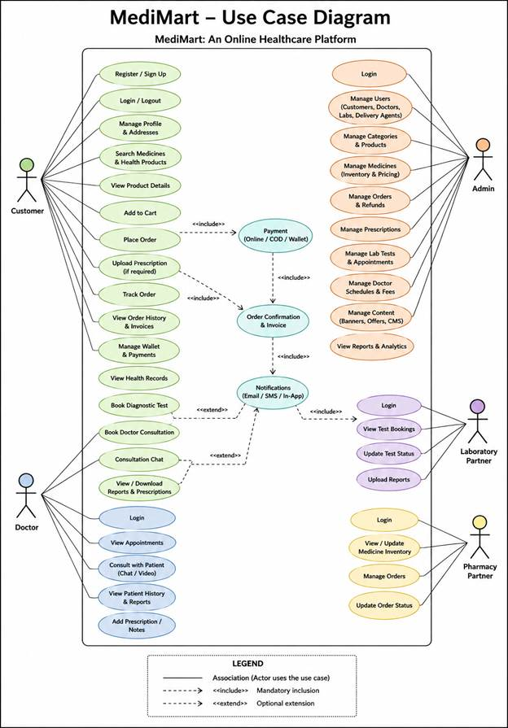
The use-case view is organized around four boundaries: public discovery, customer healthcare journeys, professional operations, and administration.
Customer use cases: register and sign in; search products, tests, doctors, and guides; manage addresses and dependents; upload prescriptions; add items to cart; pay; track, cancel, return, and review orders; book labs and consultations; view records and reminders; and contact support.
Professional use cases: sellers submit business evidence and offers; pharmacists review prescriptions and dispensing; phlebotomists manage collection steps; doctors manage profiles and consultations; delivery staff update assigned delivery states; and support staff manage tickets.
Operations use cases: compliance reviews licences; catalogue managers review publication; warehouse managers manage batches and shipments; operations managers coordinate fulfilment, finance, clinical, support, and audit work; and admins have trusted full access.

4.2 Class Diagram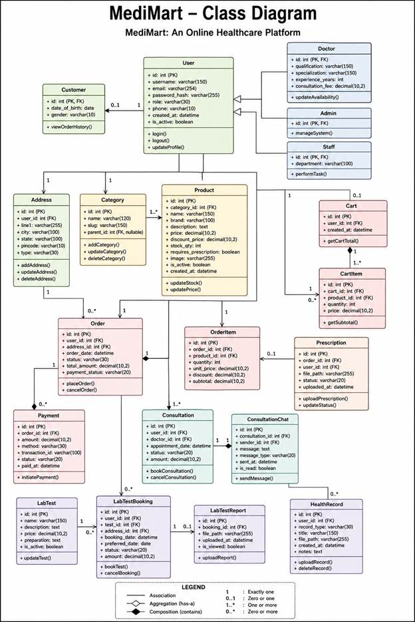
The core class relationships are: User 1--1 UserProfile; User 1--* Address, Order, Prescription, LabBooking, Consultation, HealthRecord, Notification, and SupportTicket; Product *--1 Category and Brand; Vendor 1--* VendorProduct; Product 1--* VendorProduct; Order 1--* OrderItem and OrderStatusHistory; Order 1--1 Payment and may have Shipment, ReturnRequest, and Refund; Prescription 1--* PrescriptionItem; LabPartner 1--* LabTest and LabCollectionSlot; Consultation 1--* ConsultationMessage; and InventoryBatch belongs to a seller offer and warehouse.
The model layer also stores audit actors, review decisions, notification deliveries, temperature logs, recall notices, consent records, reminders, and care-plan memberships. Foreign keys, protected deletion, status choices, validation, and database constraints preserve relationships and operational history.

4.3 Interaction Diagram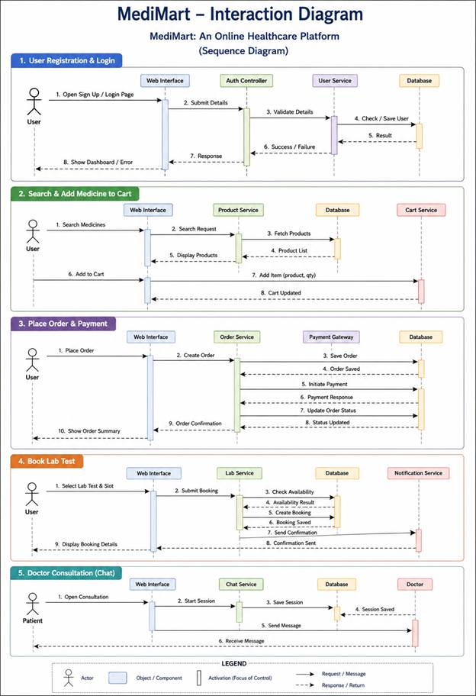

Customer -> Django view/form: submits an action with CSRF protection.
Django view -> permission layer: authenticates the session and checks the role capability.
Django view -> service/model transaction: validates business rules, writes MySQL records, and creates status history or audit events.
Payment flow: checkout -> Razorpay order -> browser checkout -> server signature/webhook verification -> Payment and Order update -> customer notification.
Prescription flow: customer upload -> private media validation -> clinical review -> pharmacist decision -> approved product and quantity gate -> fulfilment order.
Delivery flow: operations assigns delivery staff -> delivery staff issues OTP at dispatch -> customer shares OTP -> delivery staff records proof -> Shipment, Order, history, notification, and audit update.

4.4 Activity Diagram

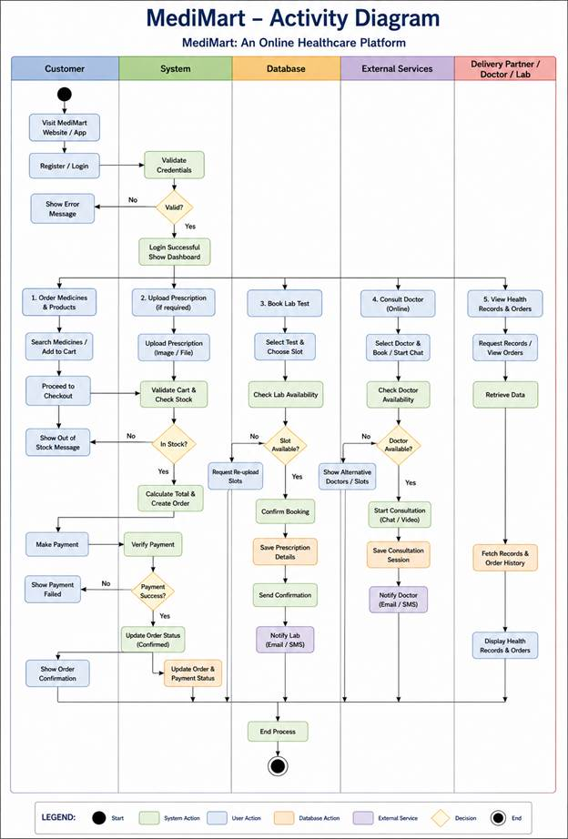
Start -> customer selects a product or healthcare service -> authentication and address check -> validation -> branch by workflow.
Medicine branch: cart -> prescription and stock checks -> checkout -> payment verification -> confirmed order -> warehouse processing -> packing -> shipment -> out for delivery -> OTP/proof -> delivered.
Lab branch: select test -> select available slot -> booking -> partner confirmation -> collection OTP and sample chain -> processing -> report ready -> secure customer report access.
Consultation branch: select verified doctor -> request slot -> payment or configured fee flow -> doctor confirmation -> private consultation -> notes/advice/prescription -> follow-up closure.
At any permitted point, validation failure returns a clear error; cancellation, rejection, return, refund, recollection, or support escalation follows its own recorded terminal or review state.

4.5 Data Dictionary

Table: Users and User Profiles
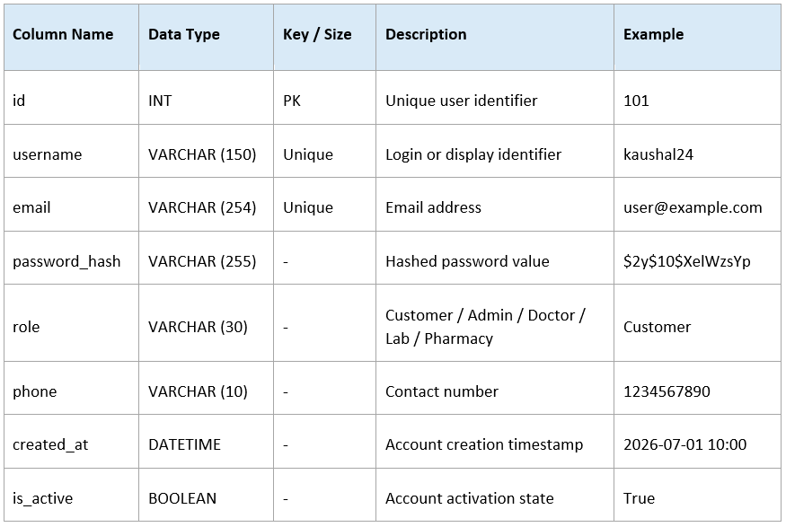

Column | Type | Key | Description | Example
id | BIGINT | PK | Django user identifier | 137
username | VARCHAR(150) | Unique | Login username | customer.hadi-momin
email | VARCHAR(254) | Indexed | Account email address | customer.hadi-momin@gmail.com
password | VARCHAR | Hash | Django password hash; never plain text | pbkdf2...
is_active / is_staff / is_superuser | BOOLEAN | - | Account state and trusted admin flags | True / False / False
role | VARCHAR(40) | Profile | MediMart role controlling capabilities | customer
mfa_enabled | BOOLEAN | Profile | Whether TOTP verification is required | False
Table: Addresses
Column | Type | Key | Description | Example
id | BIGINT | PK | Django user identifier | 137
username | VARCHAR(150) | Unique | Login username | customer.hadi-momin
email | VARCHAR(254) | Indexed | Account email address | customer.hadi-momin@gmail.com
password | VARCHAR( unusable/hash) | - | Django password hash; never store plain text | pbkdf2...
is_active | BOOLEAN | - | Whether the account can authenticate | True
role | VARCHAR(40) | FK profile | MediMart role in UserProfile | customer
mfa_enabled | BOOLEAN | Profile | Whether TOTP verification is required | False
Table: Categories
Column | Type | Key | Description | Example
id | BIGINT | PK | Address identifier | 201
user_id | BIGINT | FK | Address owner | 137
full_name / phone | VARCHAR | - | Recipient identity and contact | Hadi Momin / +91...
house_number / address_line_1 | VARCHAR / TEXT | - | House, building, street, and area | 12 Main Road
district / city / state | VARCHAR | - | Delivery location fields | Ahmedabad / Gujarat
pincode | VARCHAR(10) | Indexed | Serviceability and delivery pincode | 380001
address_type / is_default | VARCHAR / BOOLEAN | - | Home, work, other and default flag | Home / True

Table: Products
Column | Type | Key | Description | Example
id | BIGINT | PK | Category identifier | 10
name / slug | VARCHAR | Unique slug | Display and URL names | Diabetes Care
parent_id | BIGINT | FK nullable | Optional parent category | 1
description | TEXT | - | Category explanation | Products for diabetes care
is_active | BOOLEAN | - | Whether visible in catalogue | True

Table: Cart
Column | Type | Key | Description | Example
id / sku | BIGINT / VARCHAR | PK / Unique | Product identifier and catalogue SKU | 5001 / MM-MED-001
category_id / brand_id | BIGINT | FK | Catalogue classification | 10 / 4
name / product_type | VARCHAR | - | Product title and type | Paracetamol 500 mg Tablets
mrp / selling_price | DECIMAL | - | Price limits and listed selling price | 45.00 / 30.00
stock_quantity | INTEGER | - | Catalogue stock reference | 100
prescription_required | BOOLEAN | - | Whether clinical approval is required | False
safety_classification / recall_state | VARCHAR | - | OTC, prescription, controlled, quarantined, or recalled state | OTC / clear
composition / pack_size / storage | TEXT / VARCHAR | - | Clinical and product information | Paracetamol / 10 tablets / Room temperature

Table: Cart Items
Column | Type | Key | Description | Example
id | BIGINT | PK | Cart identifier | 8001
user_id | BIGINT | FK unique | Cart owner | 137
created_at / updated_at | DATETIME | - | Cart lifecycle timestamps | 2026-10-12 21:00

Table: Orders
Column | Type | Key | Description | Example
id | BIGINT | PK | Cart item identifier | 8002
cart_id | BIGINT | FK | Cart reference | 8001
vendor_product_id | BIGINT | FK | Selected seller offer | 6501
quantity | INTEGER | - | Requested quantity | 2
added_at / updated_at | DATETIME | - | Item lifecycle timestamps | 2026-10-12 21:05

Table: Order Items
Column | Type | Key | Description | Example
id / order_number | BIGINT / VARCHAR | PK / Unique | Order identifier and customer reference | 9001 / MM-ORD-2026-001200
customer_id / address_id | BIGINT | FK | Customer and selected address | 137 / 201
address_snapshot | TEXT | - | Immutable delivery details at checkout | 12 Main Road, Ahmedabad
subtotal / discount / delivery_charge | DECIMAL | - | Server-calculated charge components | 198.00 / 0.00 / 49.00
total_amount | DECIMAL | - | Final amount after charges | 247.00
payment_method / payment_status | VARCHAR | - | Payment route and state | Razorpay / paid
order_status | VARCHAR | - | Pending through delivered, returned, or refunded | processing
delivery_staff_id / timestamps | BIGINT / DATETIME | FK | Assigned courier worker and lifecycle dates | 412 / 2026-10-12

Table: Prescriptions
Column | Type | Key | Description | Example
id / order_id | BIGINT | PK / FK | Order item and parent order | 9101 / 9001
vendor_product_id / vendor_id / product_id | BIGINT | FK | Offer, seller, and catalogue product | 6501 / 31 / 5001
prescription_item_id / dispensed_batch_id | BIGINT | FK nullable | Clinical authorization and batch traceability | 7201 / 3301
product_name / seller_name / sku | VARCHAR | Snapshot | Names and SKU at order time | Paracetamol / HealthPlus / MM-MED-001
quantity | INTEGER | - | Ordered quantity | 2
unit_price / total_price | DECIMAL | - | Captured prices | 30.00 / 60.00

Table: Lab Tests
Column | Type | Key | Description | Example
id | BIGINT | PK | Prescription identifier | 7001
user_id | BIGINT | FK | Customer uploader | 137
file | Private file | Protected | Prescription image or PDF | private_media/prescriptions/p1.pdf
status | VARCHAR | - | Pending, under review, approved, rejected, or clarification | under_review
patient_name / doctor_name | VARCHAR | - | Extracted or supplied patient and doctor details | Hadi Momin / Dr. Shah
reviewed_by / reviewed_at | BIGINT / DATETIME | FK nullable | Pharmacist or authorized reviewer decision | 501 / 2026-10-12
valid_until / fulfillment_count | DATE / INTEGER | - | Expiry and permitted fulfilment tracking | 2027-01-12 / 0

Table: Lab Bookings
Column | Type | Key | Description | Example
id / name | BIGINT / VARCHAR | PK | Test or package identity | 3001 / Complete Blood Count
partner_id | BIGINT | FK | Lab partner | 18
category / sample_type | VARCHAR | - | Test category and required sample | Blood / Blood
price / mrp | DECIMAL | - | Listed and maximum price | 450.00 / 500.00
report_eta / preparation | VARCHAR / TEXT | - | Expected report time and instructions | 24 hours / Fasting required
is_home_collection / is_active | BOOLEAN | - | Collection and listing availability | True / True

Table: Doctors
Column | Type | Key | Description | Example
id / user_id | BIGINT | PK / FK | Booking and customer | 3101 / 137
lab_test_id / dependent_id | BIGINT | FK nullable | Booked test and family member | 3001 / 22
slot / address_id | DATETIME / BIGINT | FK nullable | Collection time and home address | 2026-10-14 08:30 / 201
status | VARCHAR | - | Requested, confirmed, collected, processing, report ready, or cancelled | confirmed
accession_number | VARCHAR | Unique nullable | Sample accession and chain-of-custody reference | MM-LAB-3101
report / report_ready_at | Private file / DATETIME | Protected | Secure report and release time | private_media/reports/r1.pdf

Table: Consultations
Column | Type | Key | Description | Example
id / user_id | BIGINT | PK / FK | Doctor profile and linked account | 4001 / 501
full_name / specialization | VARCHAR | - | Public professional profile | Dr. Aastha Patel / Dermatology
registration_number / medical_council | VARCHAR | - | Credential references | GJ-12345 / GMC Gujarat
qualification / qualification_document | VARCHAR / Private file | Protected | Qualification and evidence | MBBS / private_media/doctors/d1.pdf
consultation_fee / experience_years | DECIMAL / INTEGER | - | Professional pricing and experience | 499.00 / 8
is_verified / verified_by | BOOLEAN / BIGINT | FK nullable | Verification decision and reviewer | True / 2

Table: Consultation Messages
Column | Type | Key | Description | Example
id / user_id / doctor_id | BIGINT | PK / FK | Consultation, patient, and doctor | 4101 / 137 / 501
dependent_id | BIGINT | FK nullable | Family member receiving care | 22
mode / status | VARCHAR | - | Chat or configured mode and lifecycle state | chat / confirmed
symptoms / patient_history | TEXT | Private | Customer clinical context | Fever for two days
scheduled_at / followup_until | DATETIME | - | Appointment and follow-up window | 2026-10-14 17:00
clinical_notes / advice / e_prescription | TEXT / Private file | Private | Doctor-authored consultation output | Hydration advice / private file

Table: Health Records
Column | Type | Key | Description | Example
id / consultation_id | BIGINT | PK / FK | Message and consultation | 4201 / 4101
sender_id | BIGINT | FK | Customer or doctor sender | 501
message | TEXT | Private | Chat message body | Please share your report
attachment | Private file | Protected | Optional consultation attachment | private_media/chat/report.pdf
created_at / read_at | DATETIME | - | Message and read state timestamps | 2026-10-14 17:05

Table: Reviews and Operational Records
Column | Type | Key | Description | Example
id / user_id / product_id | BIGINT | PK / FK | Review, author, and product | 10001 / 137 / 5001
order_id / order_item_id | BIGINT | FK nullable | Verified purchase context | 9001 / 9101
rating | INTEGER | 1 to 5 | Customer rating | 5
title / comment | VARCHAR / TEXT | - | Review content | Good experience
is_approved / is_verified_purchase | BOOLEAN | - | Moderation and purchase verification | True / True
helpful_count / abuse_report_count | INTEGER | - | Community feedback and moderation counters | 12 / 0
The implementation also persists payments and gateway events, shipments and shipment events, returns and refunds, vendor offers and inventory batches, notifications and email deliveries, support tickets, and audit events. These records connect operational decisions to an account, status, timestamp, and reason.
Payment and fulfilment examples: Payment stores gateway identifiers, verification status, captured and refunded amounts; Shipment stores courier, tracking, promised time, OTP verification, recipient, proof, and shipment events; ReturnRequest and Refund store customer reason, review decision, inspection, refund state, and resolution.
Governance examples: Notification and NotificationDelivery store in-app/email delivery state; SupportTicket stores ownership, SLA, notes, and escalation; AuditEvent stores actor, action, target type, target id, summary, request id, and timestamp.
Column | Type | Key | Description | Example
id / user_id | BIGINT | PK / FK | Record and owner | 6001 / 137
dependent_id | BIGINT | FK nullable | Family member scope | 22
record_type / title | VARCHAR | - | Prescription, lab report, consultation, or other record | Lab report / CBC
provider / record_date | VARCHAR / DATE | - | Issuing provider and clinical date | City Lab / 2026-10-14
file | Private file | Protected | Permission-checked document | private_media/records/cbc.pdf
tags / shared_until | JSON / DATETIME | - | Search tags and time-limited sharing | ["blood"] / 2026-10-20

5. DEVELOPMENT

5.1 Development Approach
MediMart follows an Agile-oriented development approach in which the system is divided into
manageable modules and implemented incrementally. Frontend, backend, database, and testing
activities are performed in parallel with regular integration checkpoints.
· The project is organized into functional milestones such as requirements, UML / database design, authentication, catalog, cart / order, prescription, lab booking, consultation, administration, and testing.
· Django models and migrations are used to define and evolve the MySQL schema.
· Django views, forms, templates, URL routing, and application services are used to implement business workflows.
Bootstrap, Bootstrap Icons, project CSS, and JavaScript are used for responsive layout, theme switching, form feedback, search suggestions, pagination, notification timers, and progressive AJAX interactions where implemented.
· Git is used for source-code version control, and testing is performed during development rather than only at the end.

5.2 Coding Standards
Naming Conventions:
· Python Classes / Models: PascalCase (e.g., ProductView, LabBookingService)
· Python Functions / Variables: snake_case (e.g., create_order(), verify_prescription())
· Variables: snake_case, e.g., user_profile, order_total
· Constants: UPPER_CASE (e.g., UPPER_SNAKE_CASE, e.g., MAX_UPLOAD_SIZE)
· HTML / CSS / JS: for CSS: camelCase, for JS variables (e.g., itemQuantity).
Code Style Guidelines:
· Meaningful and descriptive names are used for variables, functions, classes, database fields, and other programming elements to improve code readability and maintainability.
· Functions are kept concise and focused on a single responsibility, ensuring that each function performs one specific task and avoids unnecessary complexity.
· Consistent indentation of 4 spaces is maintained throughout the source code to ensure proper formatting and readability, especially in Python and Django files.
· Comments are added wherever complex logic, important business rules, validation processes, or database operations require additional explanation.
· A clear Separation of Concerns is maintained by keeping presentation, business logic, and data management separate. HTML templates are primarily used for displaying content and do not contain complex business logic.
· Code duplication is minimized by following the DRY (Don't Repeat Yourself) principle. Common functionality is implemented through reusable functions, classes, templates, and components.
· Database tables and Django model classes follow consistent and meaningful naming conventions. Django model classes use PascalCase, such as User, Product, Order, and LabBooking, while database fields use clear and descriptive names.

5.3 GitHub Repository Details
Source code was managed using Git version control hosted on GitHub:
· Repository Name: MediMart
· Branch Structure: 'main' branch for stable production releases; 'test-env' branch for feature integration; dedicated feature branches for module development.
· Collaboration Policy: Mandatory Pull Request reviews before merging code into the 'test-env' branch.

5.4 AI tools/ Libraries/API used (If Any)
The current AI and supporting libraries are documented below:
- AI provider: A configured OpenAI-compatible endpoint is used for guarded catalogue search and conversational assistance. The provider and model are configured through environment variables, and secrets are not stored in the document.
- AI safety: Local catalogue fallback, response caching, request deduplication, timeouts, input/output limits, privacy isolation, and medical safety guidance reduce unnecessary calls and unsafe conclusions.
- Python libraries: pyotp and qrcode provide TOTP setup and Google Authenticator QR generation; Django and MySQL provide the application and persistence layer.
- AI does not diagnose, prescribe, reveal private credentials, or replace pharmacist, doctor, payment, or operations decisions.
The implementation uses AI as an assistive interface, not as a clinical authority.

5.5 Screenshots & Implementation Details
Definition:
Include screenshots of key screens/modules and explain implementation details.
[SCREENSHOT 1: LOGIN SCREEN]
Description: The entry portal allows multi-role authentication for buyers, sellers, and system
administrators, complete with security controls.
Implementation Details: Built using Django's built-in Authentication views with CSRF tokens.
Form fields use browser and server-side validation. Django stores passwords using its configured secure password-hashing hasher; plain-text passwords are never stored.
Implementation Details:
- Login accepts username, email, or phone number and supports a password visibility toggle.
- Password reset and password-change flows use Django's built-in secure forms.
- Optional TOTP MFA can be configured with a QR code for Google Authenticator.
- Successful password and MFA login redirect to the public home page.

[SCREENSHOT 2: DASHBOARD SCREEN]
Description: Control center for manufacturers to oversee stock inventory levels, evaluate pending
seller offers, fulfilment queues, and operational metrics.
Implementation Details: Uses Django ORM database aggregations to compute live order metrics.
Features live operational counts, recent order preview, delivery assignment, approval queues, low-stock visibility, and links to paginated management sections.
Implementation Details:
● Displays key performance indicators
● Shows recent transactions
● Provides quick access to major functions
● Implements role-based access control

[SCREENSHOT 3: MAIN MODULE SCREEN]
Description: Product catalogue and product-detail screens display images, specifications, seller offers, pricing, stock, safety flags, prescription requirements, comparison, and cart actions.

Implementation Details: Employs JavaScript for dynamic price calculations based on volume
inputs. JavaScript supports filters, quantity updates, search suggestions, theme controls, notification timers, and selected AJAX interactions.
Implementation Details:
● Form validation for all fields
● Search and filter functionality
● Database transactions for data integrity
● Real-time data processing

6. PROPOSED ENHANCEMENTS
The following enhancements can be considered for future versions of the MediMart platform to
improve its functionality, security, accessibility, and overall healthcare-service experience:
Mobile application development.
Advanced payment operations.
Razorpay checkout and webhook verification are implemented; future work includes provider reconciliation, settlement operations, chargebacks, and production finance controls.
3. AI-Based Health Recommendations.
Introduce AI-based recommendation features to analyze user searches, purchase history, and healthcare preferences and provide relevant health products, diagnostic packages, or general health-related recommendations. Such features would be designed as assistance and would not replace professional medical advice.
4. Real-Time Notifications and Communication.
Implement real-time notifications through email, SMS, or push notifications for order updates, prescription verification, lab appointment reminders, consultation schedules, report availability, and other important account activities.
5. Advanced Security and Privacy Features.
Strengthen the protection of sensitive healthcare information by introducing enhanced authentication, secure file storage, improved access controls, activity monitoring, regular security audits, and additional privacy mechanisms for prescriptions, reports, and consultation records.
6. Performance and System Scalability.
Improve system performance and scalability through database optimization, caching, efficient queries, indexing, pagination, optimized file handling, and improved server configuration. These enhancements will help MediMart support a larger number of users, products, bookings, and healthcare records efficiently.

7. CONCLUSION
MediMart is a web-based healthcare platform that combines medicines, health products, prescription management, diagnostic test booking, doctor consultation, and health-record management in one system. It makes healthcare services more organized, convenient, and accessible for users.
The platform supports user registration, multi-identifier login, optional MFA, product search, cart management, prescription upload and review, medicine ordering, Razorpay payment verification, delivery tracking, lab-test booking, doctor consultation, health records, support, and role-scoped operations. It provides separate functions for customers, sellers, manufacturers, pharmacies, pharmacists, phlebotomists, doctors, delivery staff, support, compliance, catalogue, warehouse, operations, and admin users.
Django manages application and database operations, while MySQL stores users, profiles, products, offers, orders, prescriptions, bookings, consultations, payments, fulfilment, and health records.
The project follows an Agile development approach that includes planning, design, development, testing, and documentation. Security, usability, performance, and data accuracy are also considered during development.
MediMart is an academic project and does not replace professional medical advice, laboratory services, or medicine dispensing. Production deployment still requires approved provider credentials, legal review, operational policies, private storage, monitoring, backup drills, and real-world partner verification.
Overall, MediMart provides a useful foundation for a centralized digital healthcare platform that brings several healthcare services together in one application.

8. BIBLIOGRAPHY
The following official documentation and online technical resources were referred to during the analysis, design, development, and documentation of the MediMart project:
- Django Software Foundation. https://docs.djangoproject.com/
- Python Software Foundation. https://docs.python.org/
- Oracle Corporation. https://dev.mysql.com/doc/refman/8.4/en/
- Bootstrap Team. https://getbootstrap.com/docs/
- Tailwind Labs. https://tailwindcss.com/docs
- GitHub, Inc. https://docs.github.com/
- Django Software Foundation. https://docs.djangoproject.com/en/6.1/topics/security/

